Efficient Secure Data Retrieval on Cloud using Multi-Stage Authentication and Optimized Blowfish Algorithm

Now-a-days all organizations such as Online Social Networks, Healthcare Banking and many more are migrating their applications to cloud environment as cloud servers will provide heavy storage and computation in cheaper cost but still some organizations are hesitating to store their data in Cloud due to security issues as their data are saved at 3rd party cloud servers away from their reached and cloud servers or attackers may hack and misuse that data.

To overcome from this problem many encryption and authentication techniques such as biometric verifications are introduced but this require extra devices or hardware and existing AES algorithms require heavy computation and to overcome from this problem author of this paper introduce novel concept called multi-stage authentication with efficient data storage and retrieval using optimized Blowfish security algorithm.

This paper consists of 3 modules such as authentication, data security and retrieval

Blowfish algorithm is optimized for efficiency by applying Crow search algorithm for key generation and selection where selected keys fitness will be evaluated to check it should not easy to hack

Multi-stage authentication is applied by allowing user to get register with the application by giving username and password and then display list of images to user and then user has to select one image from the list and this image get cropped and store in database.

While login multi authentication is applied by asking user to enter username and password and if login successful then display list of images and user has to select correct image given at registration and if correct image is selected then only allow user to upload and download file.

Below code showing data encryption with key generation using Blowfish algorithm

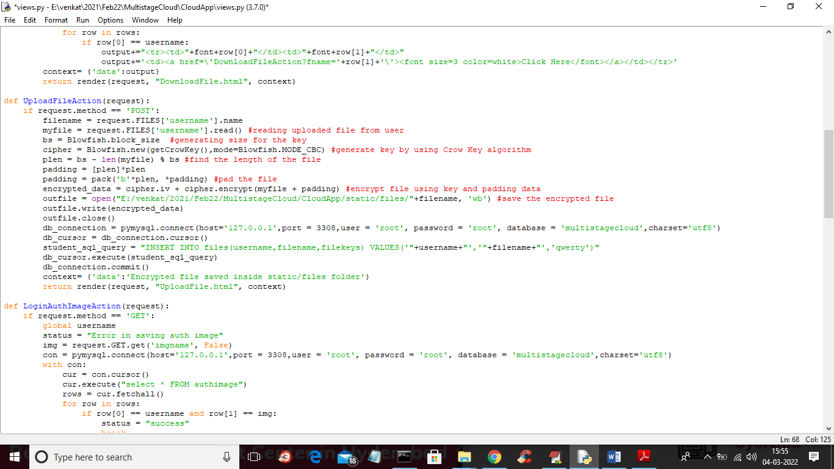

In above screen read red colour comments to know about Blowfish algorithm

SCREEN SHOTS

To run project first create database in MYSQL by copying content from ‘database.txt’ file and paste in MYSQL

Now double click on ‘runServer.bat’ file to start server and get below screen

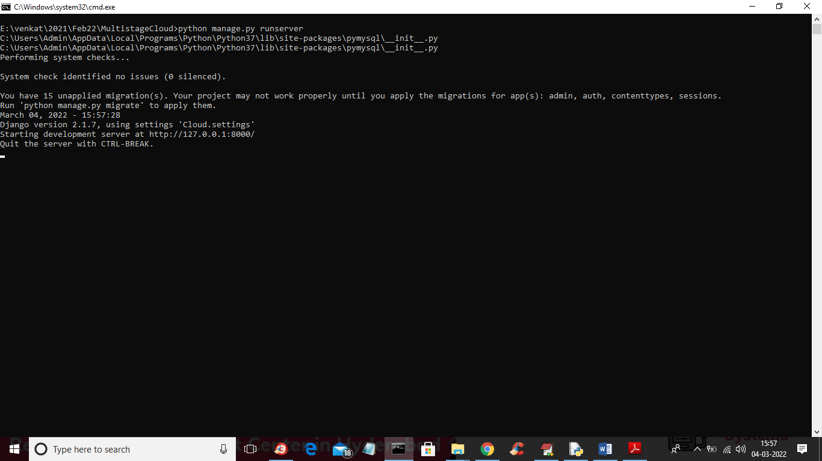

In above screen server started and now open browser and enter URL as <http://127.0.0.1:8000/index.html> and press enter key to get below screen

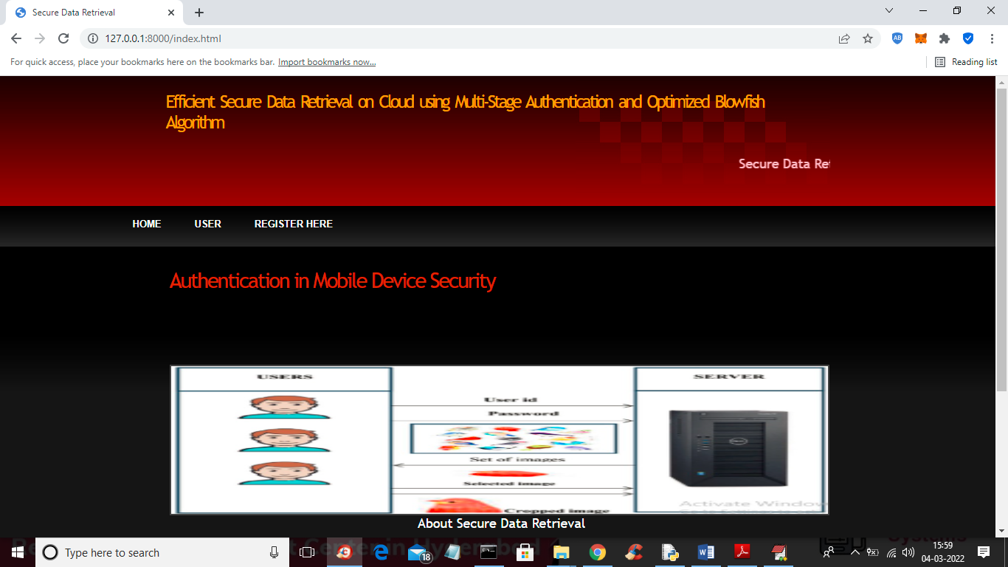

In above screen click on ‘Register Here’ link to allow user to register

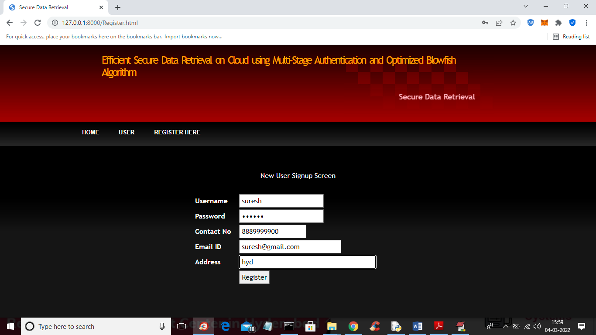

In above screen user is enter signup details and then click on ‘Register’ button o get below images screen

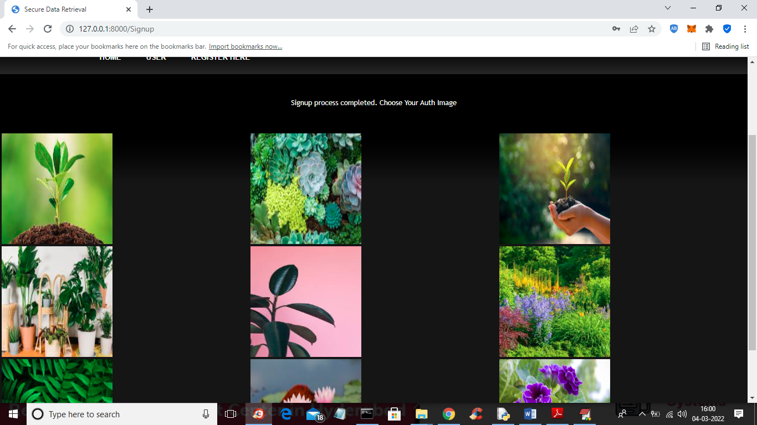

In above screen user has to click on desired image as second authentication and to get below output

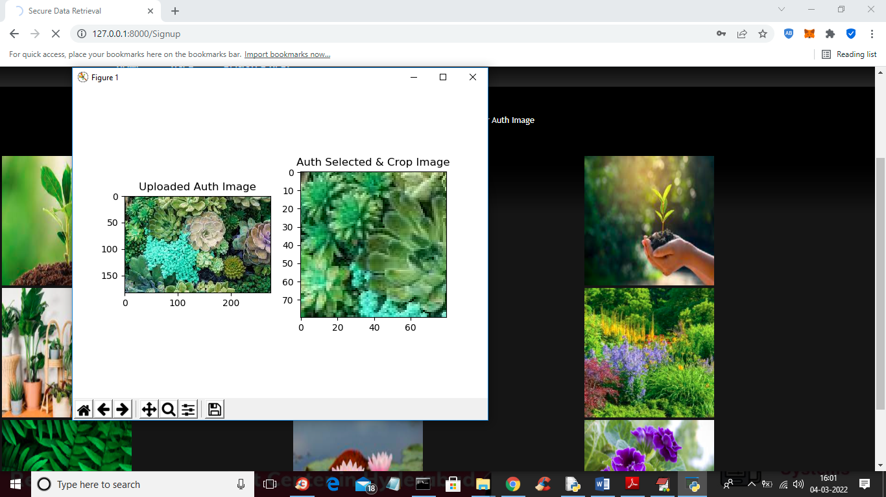

In above screen user can see selected and cropped image and then close above image to store on server and to get below screen

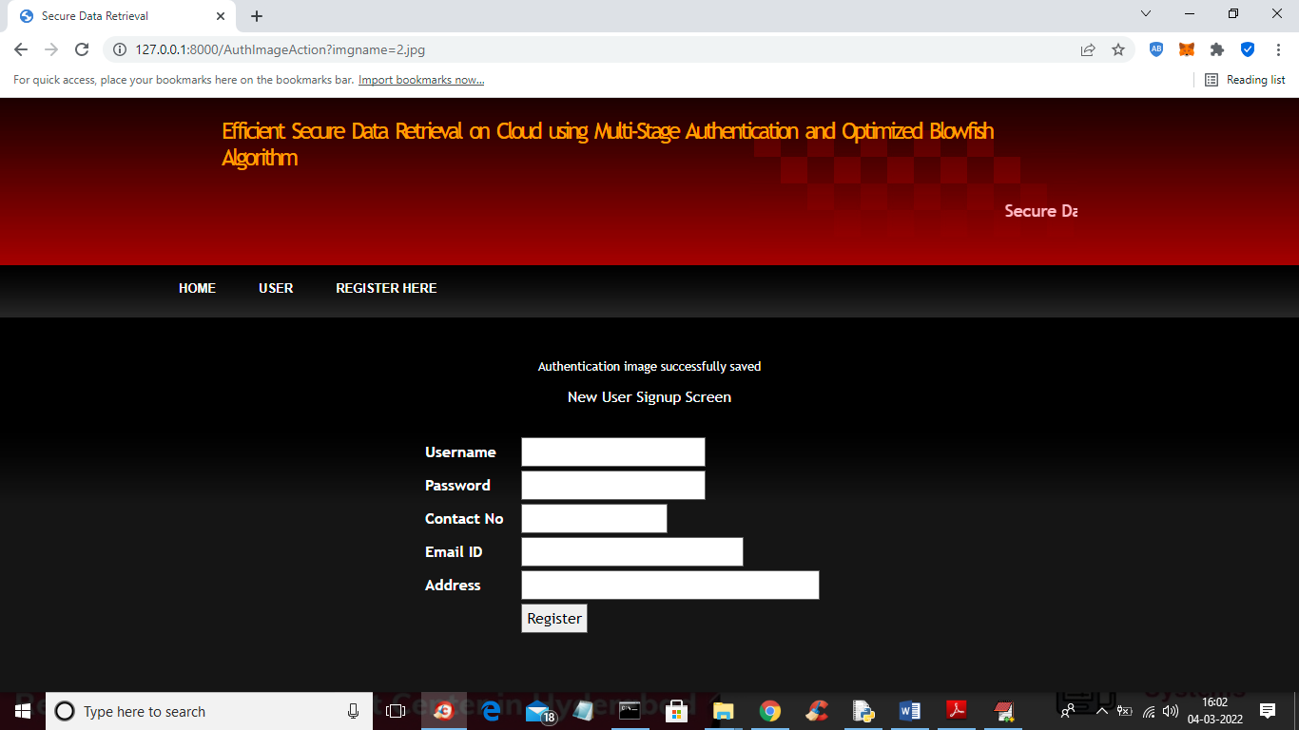

In above screen signup process completed and now click on ‘User’ link to get below login screen

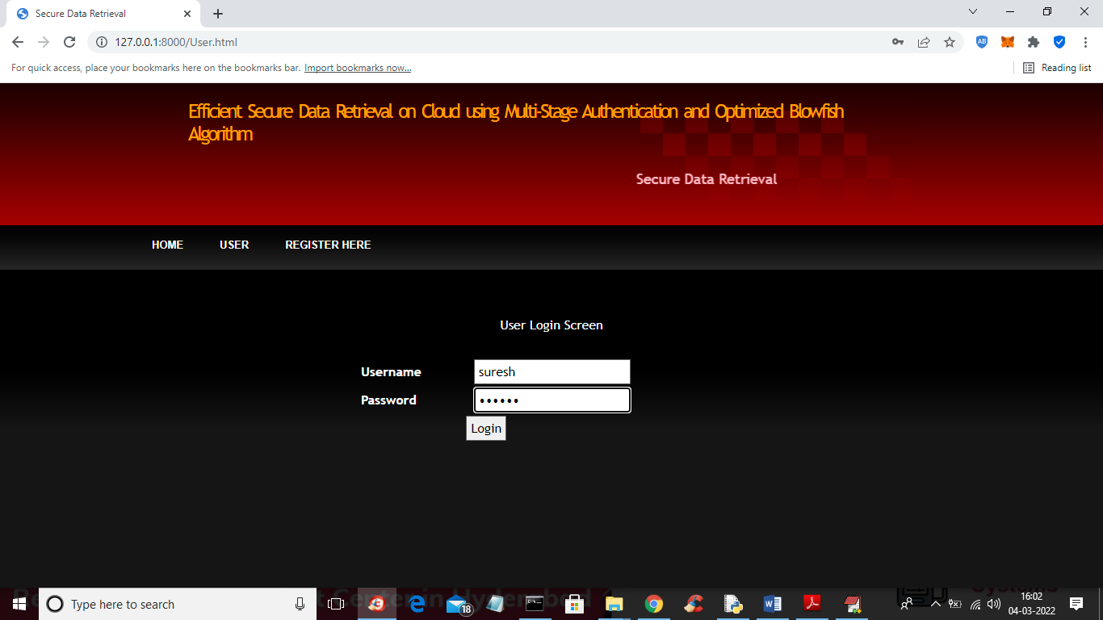

In above screen as first authentication user has to enter login details and press button to get below screen

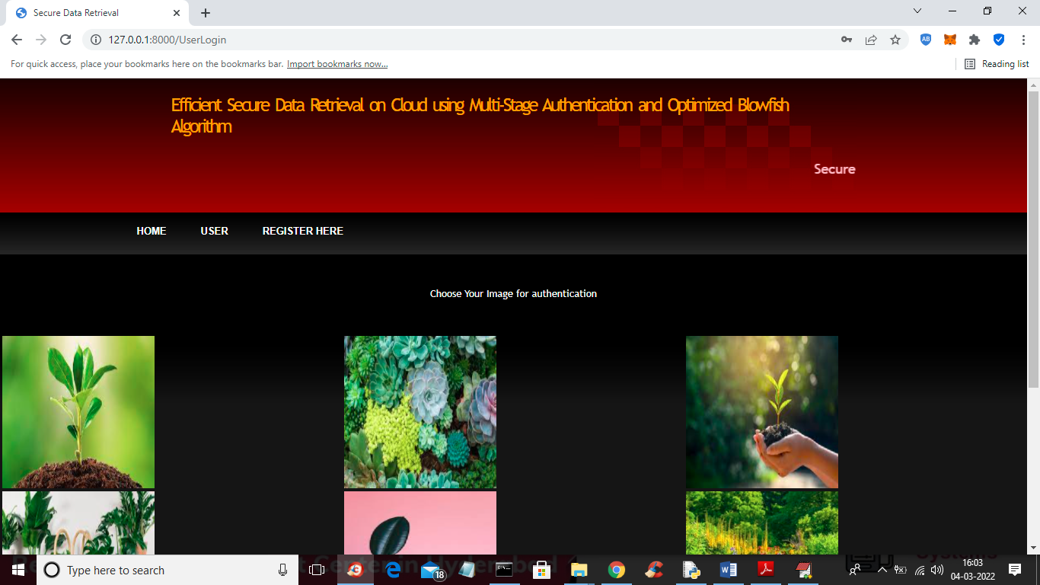

In above screen user has to click on correct image as second authentication and if image is authenticated then will get below output

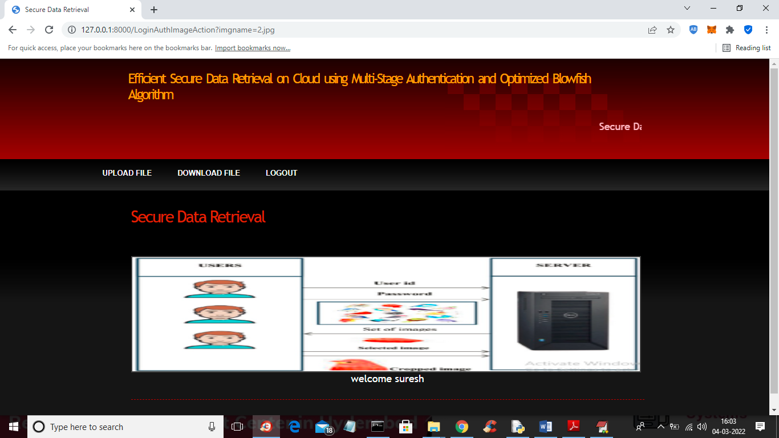

In above screen user has click on ‘Upload File’ link to get below screen

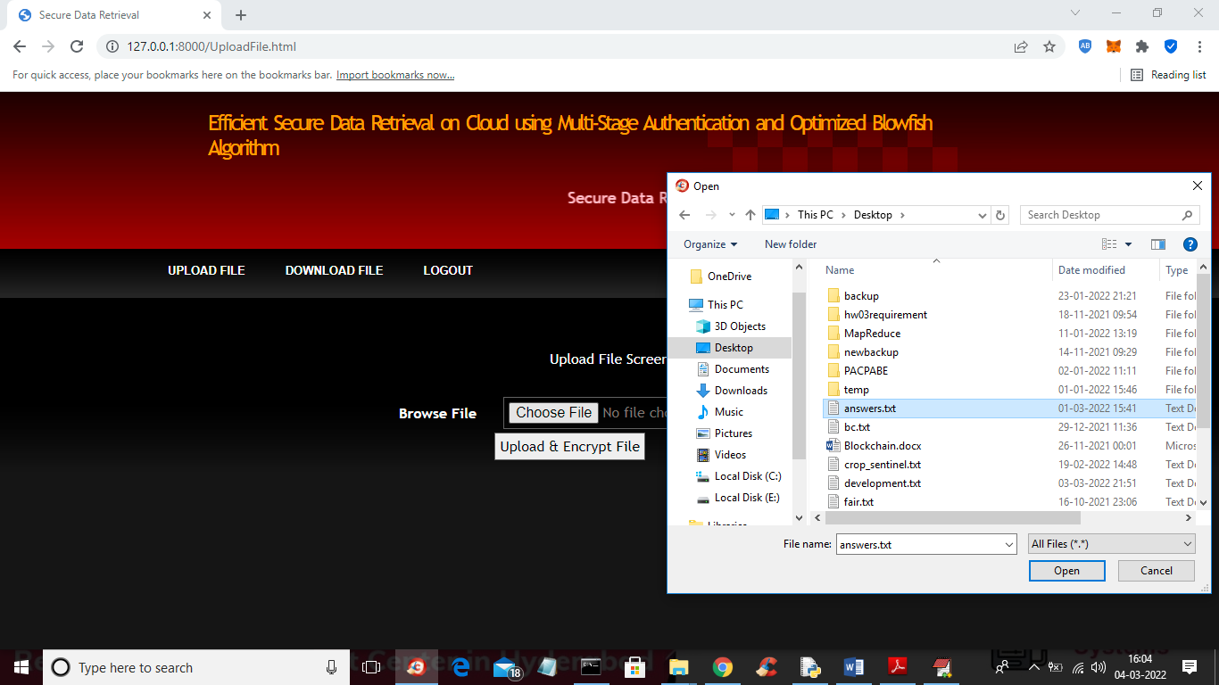

In above screen selecting and uploading file and then click on ‘Open and Upload & encrypt’ button to get below screen

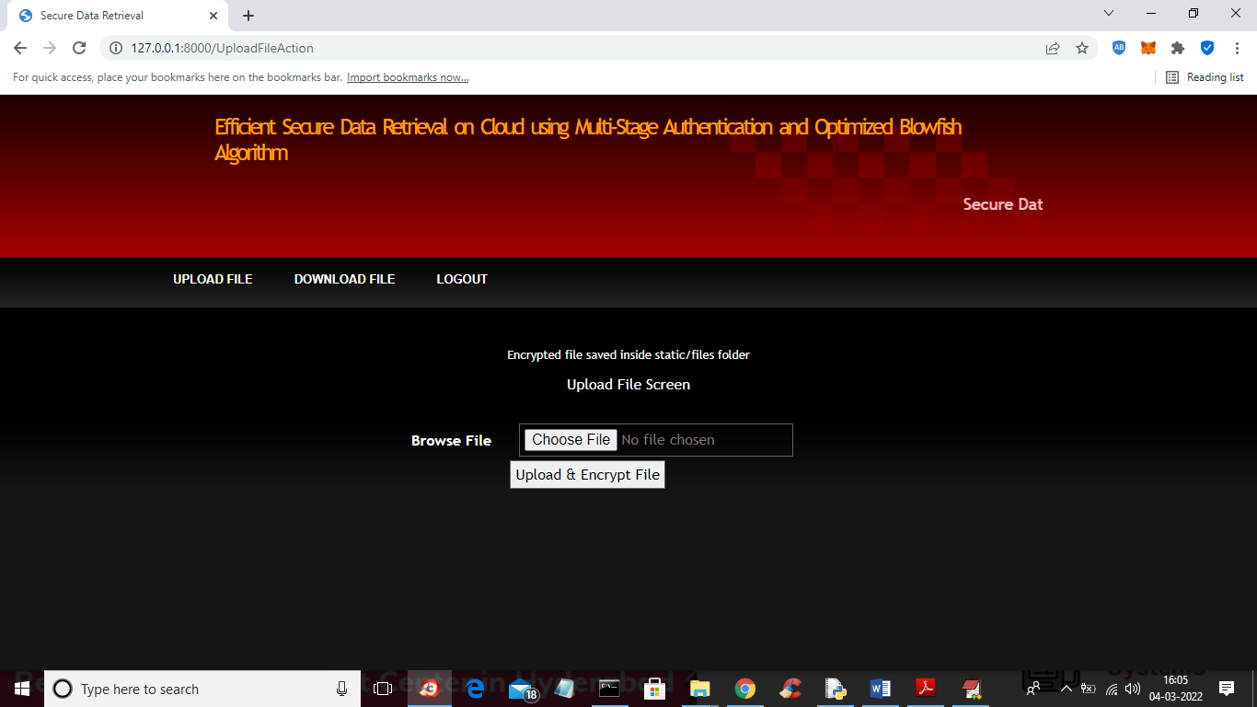

In above screen we can see file saved in server static folder and in that file we can see files saved in Blowfish encrypted format like below screen

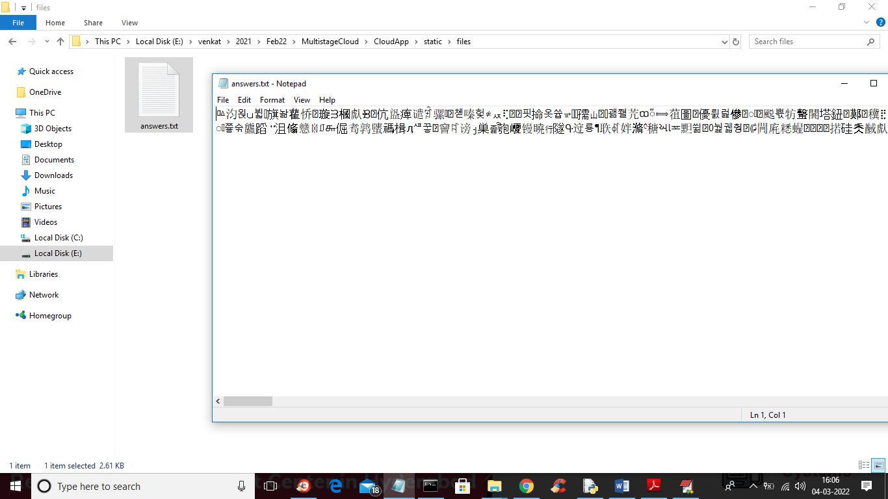

In above screen we can see file saved in encrypted format and now click on ‘Download File’ link in output screen to get below screen

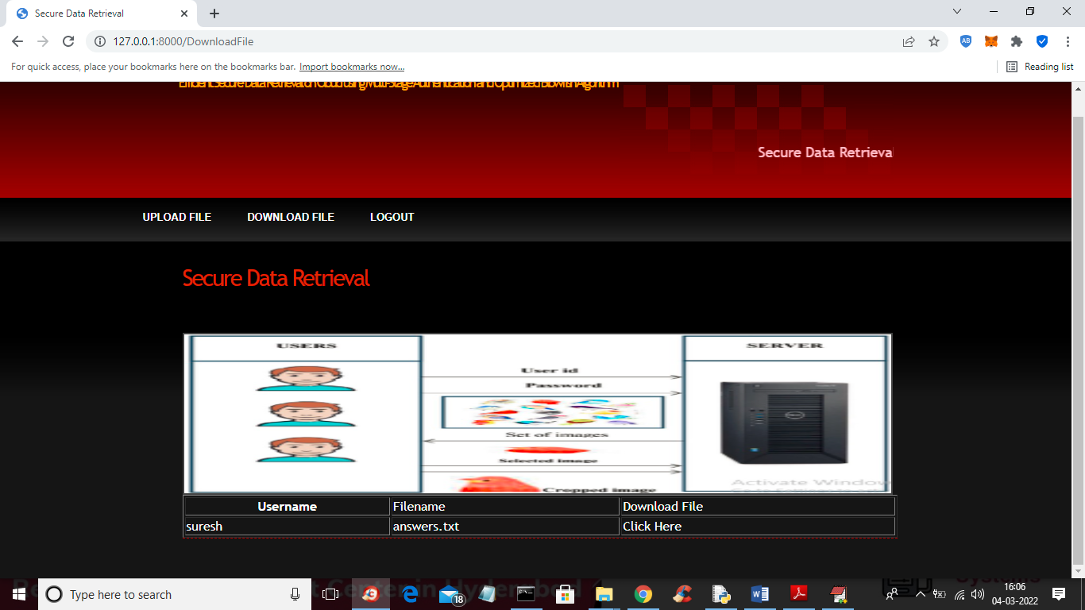

In above screen in table we can see all files uploaded by user and then click on ‘Click Here’ link to download that file in decrypted format

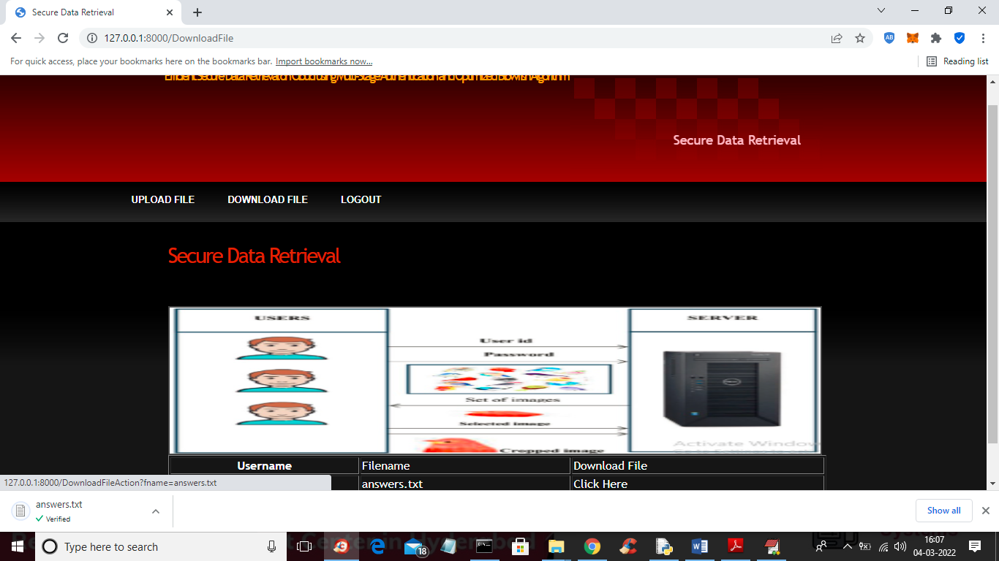

In above screen in browser status bar we can see file downloaded and now open that file to view decrypted content

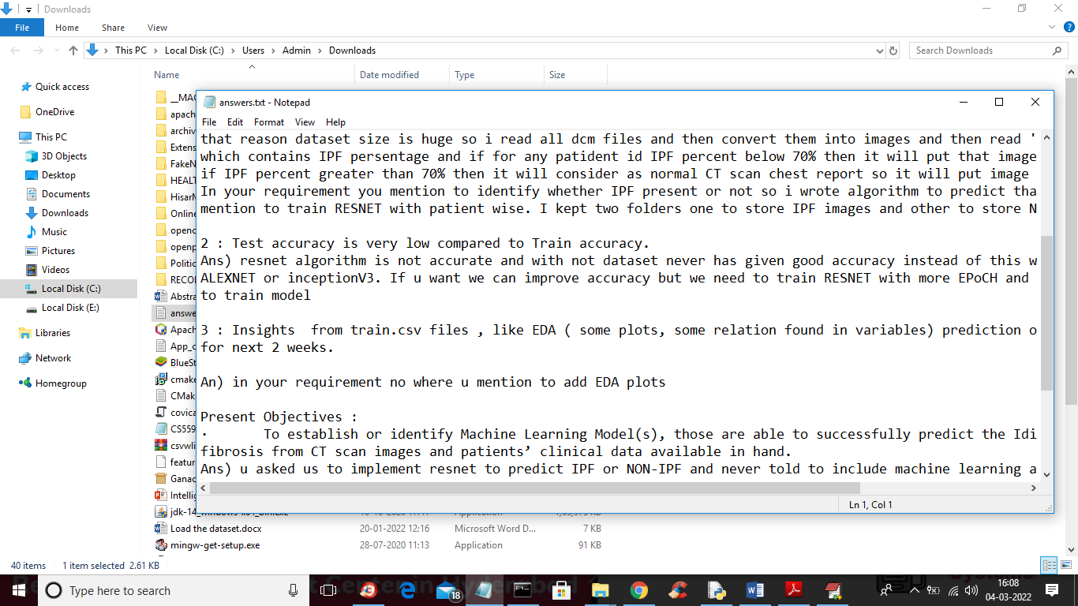

In above screen we can see file is decrypted and similarly you can upload and download any number of files